Step 1:If we encounter a database already existing error…

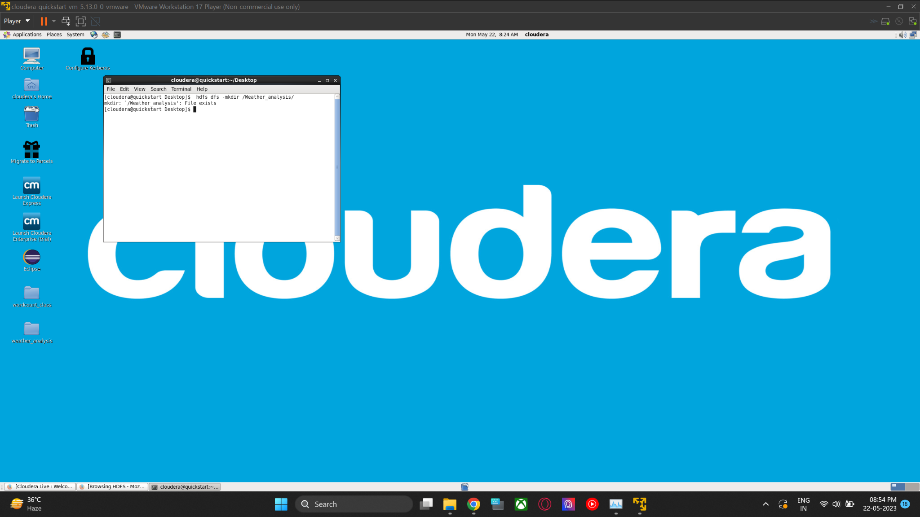

Step 2: To resolve this issue, execute the following command to delete the file from Hadoop.

**$ hadoop fs -rm -r /word_count**

**$ hadoop fs -rm -r /Weather_analysis**

